ON THE SLIDE WHERE YOU WILL PICK THE CHARACTER
- Insert the character images onto the slide
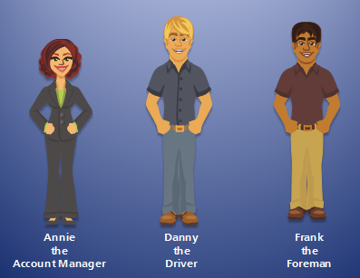
- Create a T/F Variable for each character with the default value = false
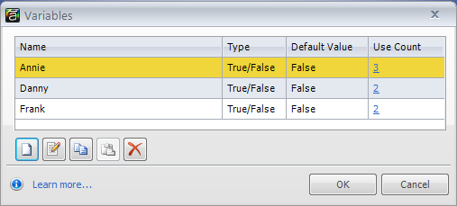
- Create a trigger for each character image and move the object triggers to the top of the trigger list (above any player triggers)
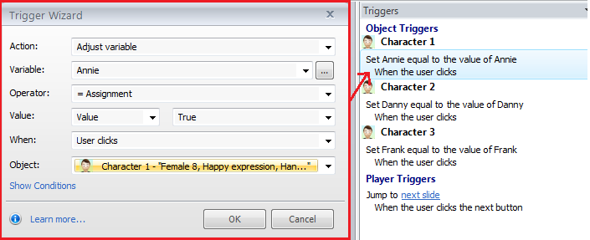

ON SLIDES WHERE YOU WANT YOUR CHARACTER TO APPEAR
- Insert one of the characters as a placeholder
- Create a state for the placeholder for each of the possible characters that could show
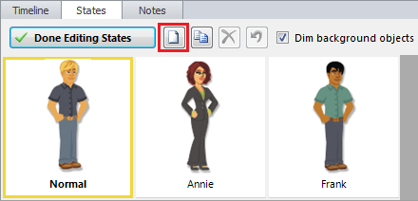
- Create a trigger for all characters
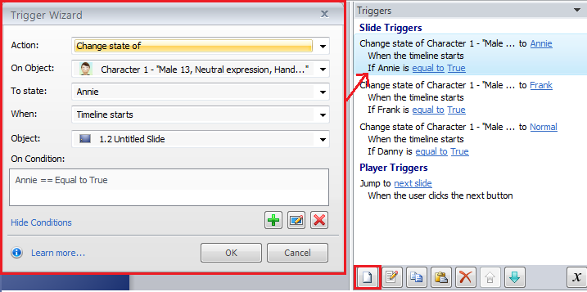
- Change the slide settings on all slides so that if user returns to the slide, it resets
